DecodeLabs — Industrial Training Kit
Project 2: Data Classification Using AI

1. Objective
The goal of this project is to build a basic supervised learning classification model that can categorize new data into known classes based on patterns learned from historical data. The Iris flower dataset was used as the benchmark, and a K-Nearest Neighbors (KNN) classifier was trained, tested, and validated end-to-end.

2. Dataset Overview
- Samples: 150 (50 per class — perfectly balanced)
- Classes: Setosa, Versicolor, Virginica
- Features: Sepal Length, Sepal Width, Petal Length, Petal Width (all in cm)

3. Methodology / Pipeline
Stage | Detail
Input | Iris dataset – 150 samples, 4 features (sepal/petal length & width), 3 balanced classes
Preprocessing | StandardScaler applied (mean = 0, variance = 1) to remove feature-scale bias
Split | 80% training (120 samples) / 20% testing (30 samples), stratified and shuffled
Model Tuning | K tested from 1–20 using the Elbow Method; optimal K = 1 selected
Algorithm | K-Nearest Neighbors (KNeighborsClassifier) – Instantiate, Fit, Predict workflow
Output | Confusion Matrix, Accuracy, Precision, Recall, F1-Score

4. Choosing the Optimal K
K values from 1 to 20 were tested and the error rate was plotted for each. The 'elbow' of the curve indicates the point of best bias-variance trade-off. For this run, K = 1 produced the lowest error rate (3.33%).
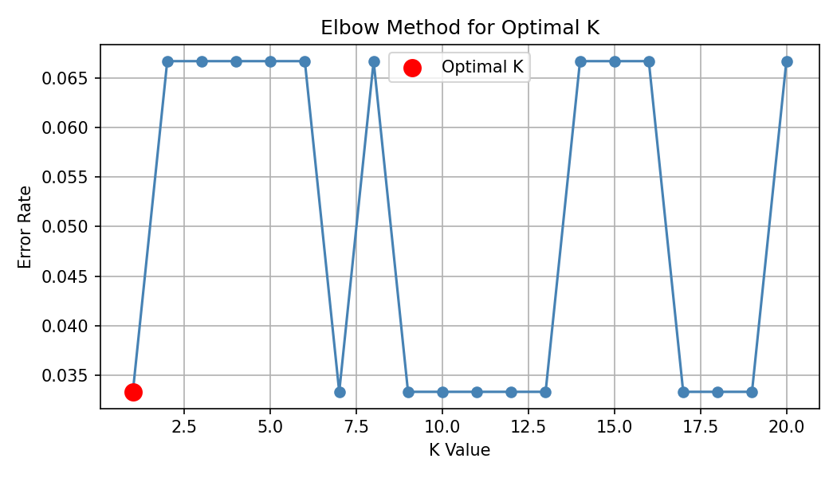

5. Results

5.1 Confusion Matrix
Out of 30 test samples, 29 were classified correctly. Only 1 Virginica sample was misclassified as Versicolor.
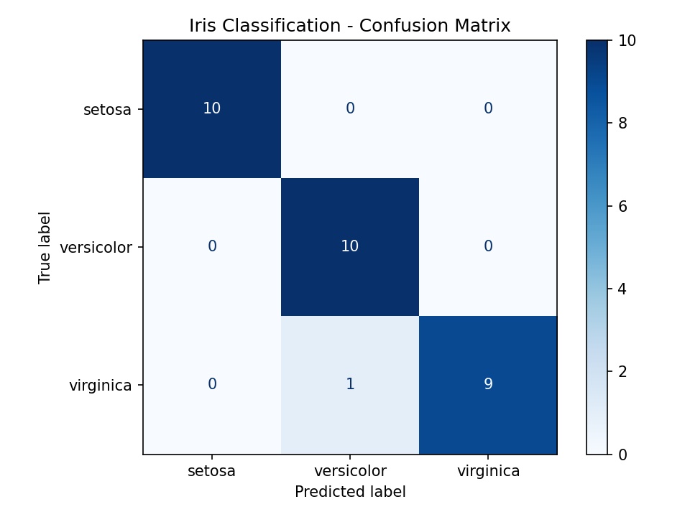

5.2 Classification Metrics
Class | Precision | Recall | F1-Score
Setosa | 1.00 | 1.00 | 1.00
Versicolor | 0.91 | 1.00 | 0.95
Virginica | 1.00 | 0.90 | 0.95
Overall Accuracy |  |  | 96.67%

6. Conclusion
The KNN model achieved 96.67% accuracy on unseen test data, with strong precision and recall across all three classes. The single misclassification occurred between Versicolor and Virginica — the two classes that are known to have overlapping petal measurements. This confirms the model successfully learned the underlying decision boundaries from the training data without overfitting (validated via the optimal-K elbow analysis).

7. Tools & Libraries Used
- Python 3 / scikit-learn
- pandas, numpy — data handling
- matplotlib, seaborn — visualization
- Algorithm: K-Nearest Neighbors (KNeighborsClassifier)

